**QUESTIONS CLASS-6**

**NOTE**

* **Kindly follow the instructions given in PPT T1-Turtle Graphics to enable scripting mode for Turtle in IDLE.**
* **Kindly go through PPT T2-Turtle Features and PPT T3 – Other Turtle Features attached in Mail before starting this Worksheet.**

1. Draw a circle of radius 100 pixels. Fill the circle with “violet” color and “black” outline.
2. Draw a square of side length 200 pixels. Fill the square with “pink” color and “black” outline.
3. Draw another square of side length 100 pixels inside the 200-pixel square. Both the squares should be concentric. Fill the bigger square with “violet” color and “black” outline and the smaller square with “pink” color and “black” outline.

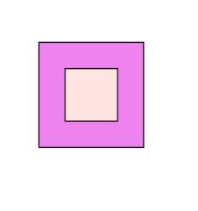

1. Draw a circle of radius 100 pixels inside another circle of radius 200 pixels. Both the circles should be concentric. Fill the bigger circle with “violet” color and “black” outline and the smaller circle with “pink” color and “black” outline.

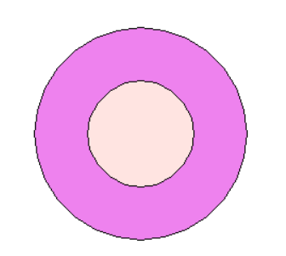

1. Write a Python program using Turtle in Python to draw the following image:

